**LAB 07 TASKS**

**Question#01)** Write a C++ program to input an upper bound by user and print all numbers up to that limit?

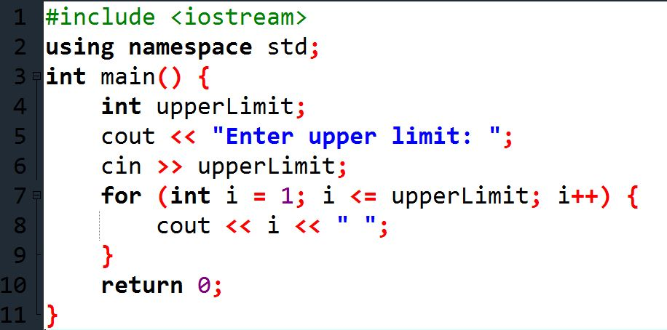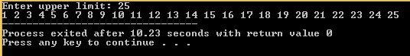**Source Code** **Output**

**Question#02)** Write a C++ program to input an upper bound and separate even & odd from that limit?

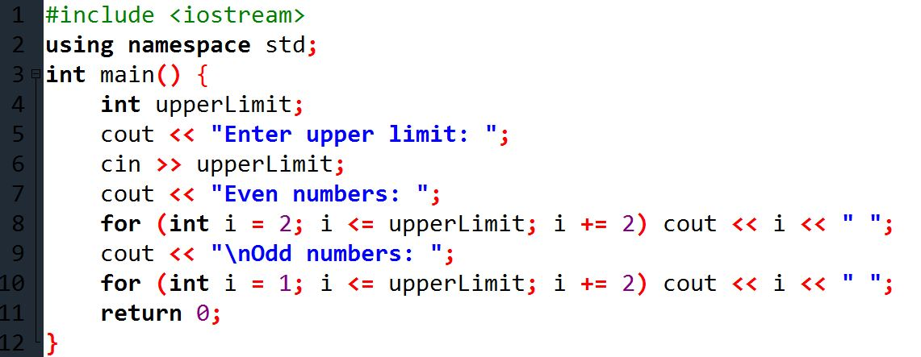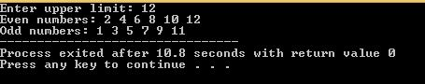**Source Code** **Output**

**Question #03)** Write a C++ program that prints complete alphabets using for loop? (a-z)

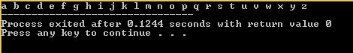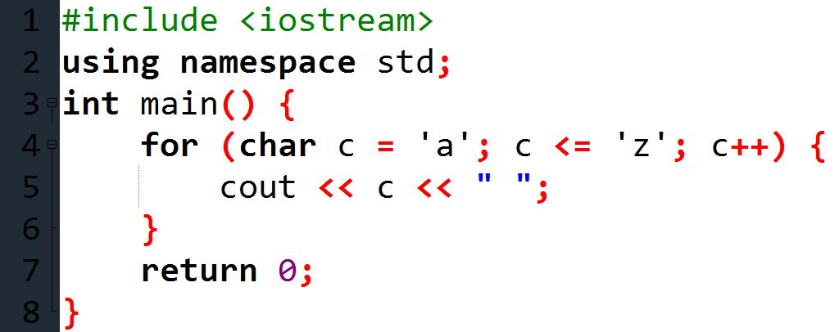**Source Code** **Output**

**Question #04)** Write a C++ program that ask the user a number and prints the table of that number up to 10?

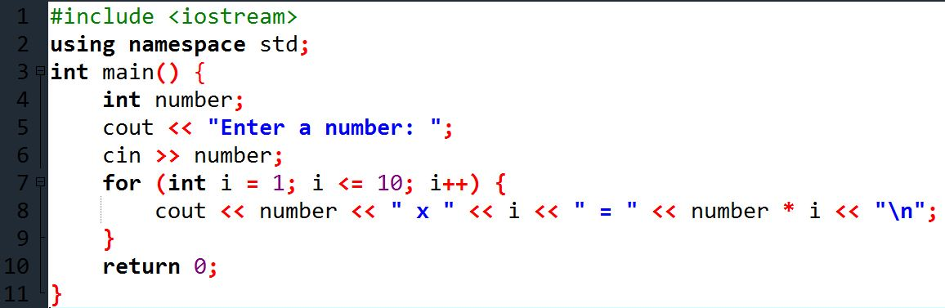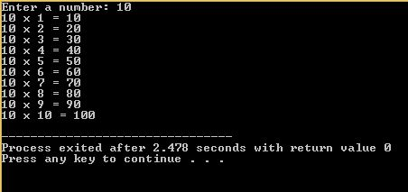**Source Code** **Output**

**Question #05)** Write a C++ program that displays the product of all odd numbers from 1 to 10 using for loop?

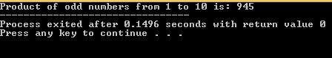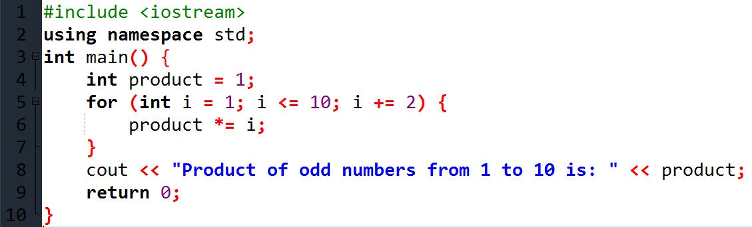**Source Code** **Output**

**Question #06)** Write a C++ program that finds the sum of squares of integer from 1 to n. Where n is a positive value entered by user (i.e. .

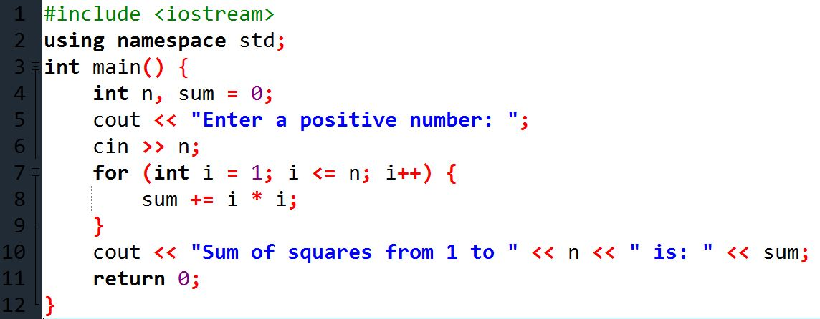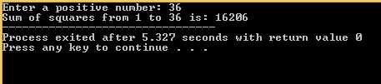**Source Code** **Output**

**Question #07)** Write a C++ program counts the number of digits in the number entered by user?

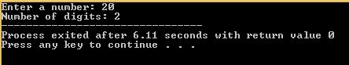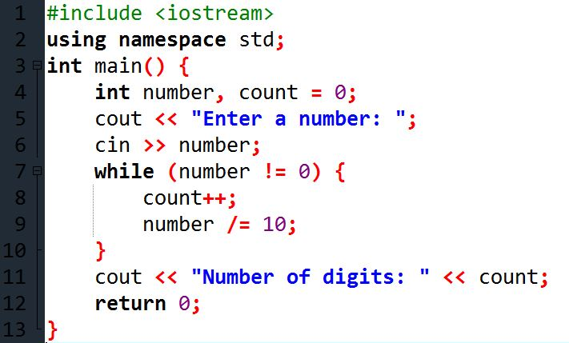**Source Code** **Output**

**Question # 08)** Write a C++ program to reverse a number entered by user using loop.

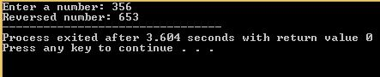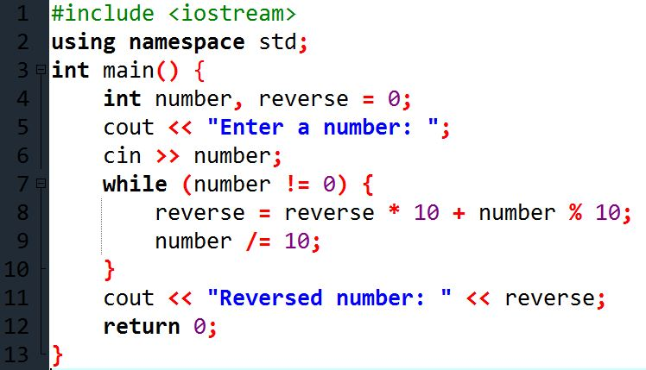**Source Code** **Output**

**Question # 09)** Write a [program to find first and last digit of a number](https://codeforwin.org/2015/06/how-to-find-first-and-last-digit-of-any-number.html).

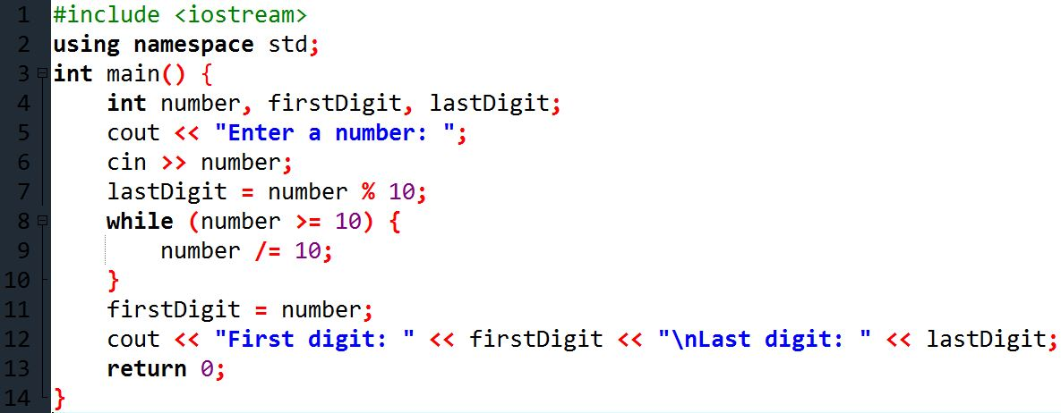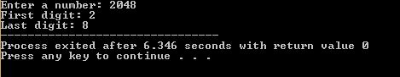**Source Code** **Output**

**Question # 10)** Write a [program to calculate product of digits of a number](https://codeforwin.org/2015/06/c-program-to-calculate-product-of-digits.html).

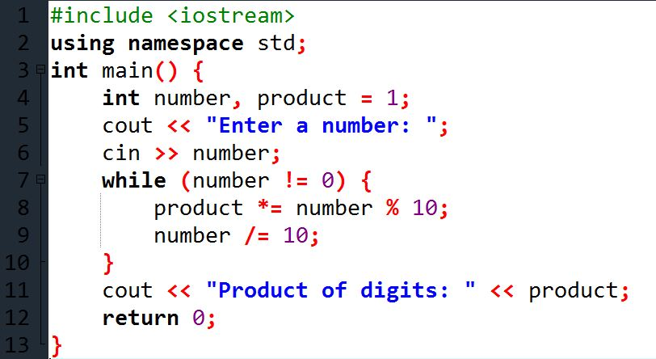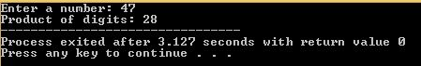**Source Code** **Output**

**Question # 11)** Write a [program to find frequency of each digit in a given integer](https://codeforwin.org/2016/10/c-program-to-count-frequency-of-digits-in-number.html).

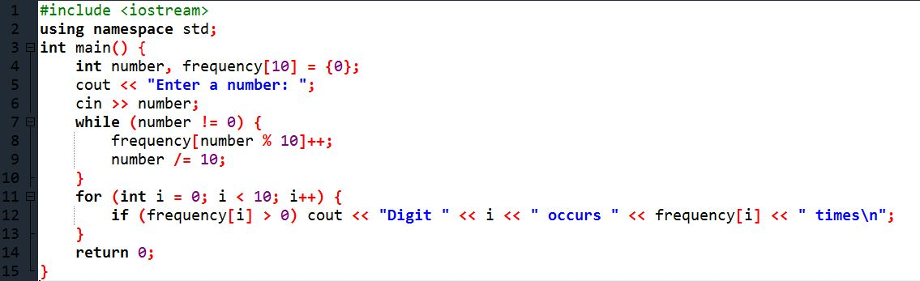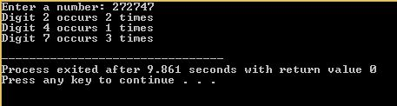**Source Code** **Output**

**Question # 12)** Write a [program to check whether a number is Armstrong number or not.](https://codeforwin.org/2015/06/c-program-to-check-armstrong-number.html)

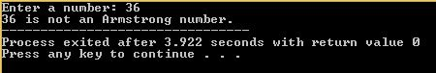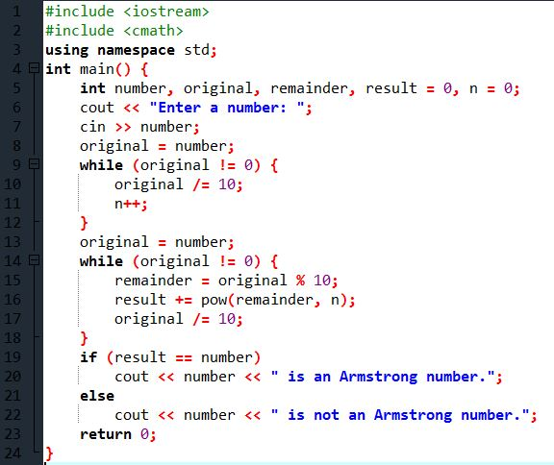**Source Code** **Output**

**Question # 13)** Write a [program to convert Binary to Decimal number system](https://codeforwin.org/2015/08/c-program-to-convert-binary-to-decimal-number-system.html).

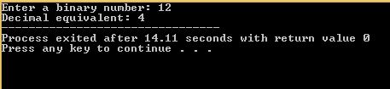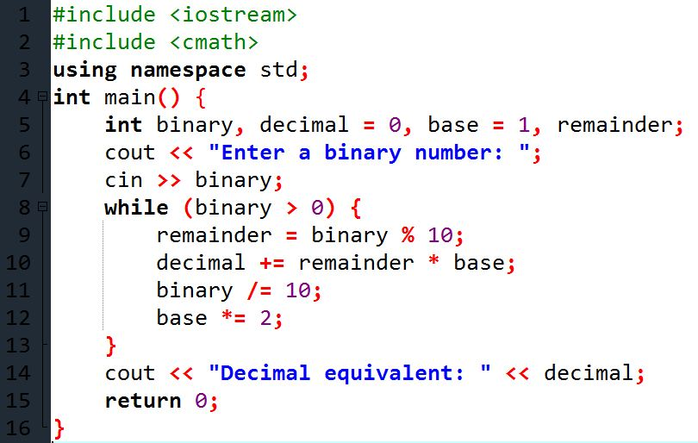**Source Code** **Output**

**Question # 14)** Write a [program to print Pascal triangle upto n rows](https://codeforwin.org/2015/07/c-program-to-print-pascal-triangle.html).

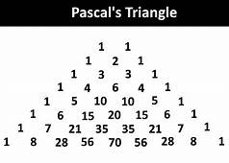

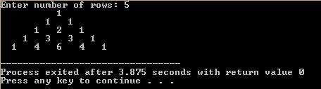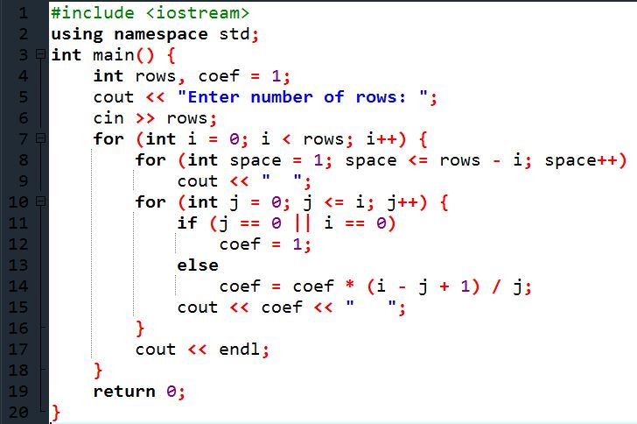**Source Code** **Output**

**Question # 15)** Write a program to print following patterns by using nested loops.

[*****](https://codeforwin.org/2015/07/rhombus-star-pattern-program-in-c.html)

[*****](https://codeforwin.org/2015/07/rhombus-star-pattern-program-in-c.html)

[*****](https://codeforwin.org/2015/07/rhombus-star-pattern-program-in-c.html)

[*****](https://codeforwin.org/2015/07/rhombus-star-pattern-program-in-c.html)

[*****](https://codeforwin.org/2015/07/rhombus-star-pattern-program-in-c.html)

[Rhombus Star Pattern](https://codeforwin.org/2015/07/rhombus-star-pattern-program-in-c.html)

[*****](https://codeforwin.org/2015/07/c-program-to-print-hollow-rhombus-star-pattern.html)

[* *](https://codeforwin.org/2015/07/c-program-to-print-hollow-rhombus-star-pattern.html)

[* *](https://codeforwin.org/2015/07/c-program-to-print-hollow-rhombus-star-pattern.html)

[* *](https://codeforwin.org/2015/07/c-program-to-print-hollow-rhombus-star-pattern.html)

[*****](https://codeforwin.org/2015/07/c-program-to-print-hollow-rhombus-star-pattern.html)

[Hollow Rhombus Star Pattern](https://codeforwin.org/2015/07/c-program-to-print-hollow-rhombus-star-pattern.html)

[*****](https://codeforwin.org/2015/07/inverted-rhombus-star-pattern-program-in-c.html)

[*****](https://codeforwin.org/2015/07/inverted-rhombus-star-pattern-program-in-c.html)

[*****](https://codeforwin.org/2015/07/inverted-rhombus-star-pattern-program-in-c.html)

[*****](https://codeforwin.org/2015/07/inverted-rhombus-star-pattern-program-in-c.html)

[*****](https://codeforwin.org/2015/07/inverted-rhombus-star-pattern-program-in-c.html)

[Mirrored Rhombus Star Pattern](https://codeforwin.org/2015/07/inverted-rhombus-star-pattern-program-in-c.html)

[*****](https://codeforwin.org/2015/07/c-program-to-print-hollow-mirrored-rhombus-star-pattern.html)

[* *](https://codeforwin.org/2015/07/c-program-to-print-hollow-mirrored-rhombus-star-pattern.html)

[* *](https://codeforwin.org/2015/07/c-program-to-print-hollow-mirrored-rhombus-star-pattern.html)

[* *](https://codeforwin.org/2015/07/c-program-to-print-hollow-mirrored-rhombus-star-pattern.html)

[*****](https://codeforwin.org/2015/07/c-program-to-print-hollow-mirrored-rhombus-star-pattern.html)

[Hollow Mirrored Rhombus Star Pattern](https://codeforwin.org/2015/07/c-program-to-print-hollow-mirrored-rhombus-star-pattern.html)

[*](https://codeforwin.org/2015/07/right-triangle-star-pattern-program-in-c.html)

[**](https://codeforwin.org/2015/07/right-triangle-star-pattern-program-in-c.html)

[***](https://codeforwin.org/2015/07/right-triangle-star-pattern-program-in-c.html)

[****](https://codeforwin.org/2015/07/right-triangle-star-pattern-program-in-c.html)

[*****](https://codeforwin.org/2015/07/right-triangle-star-pattern-program-in-c.html)

[Right Triangle Star Pattern](https://codeforwin.org/2015/07/right-triangle-star-pattern-program-in-c.html)

[*](https://codeforwin.org/2015/07/c-program-to-print-hollow-right-triangle-star-pattern.html)

[**](https://codeforwin.org/2015/07/c-program-to-print-hollow-right-triangle-star-pattern.html)

[* *](https://codeforwin.org/2015/07/c-program-to-print-hollow-right-triangle-star-pattern.html)

[* *](https://codeforwin.org/2015/07/c-program-to-print-hollow-right-triangle-star-pattern.html)

[*****](https://codeforwin.org/2015/07/c-program-to-print-hollow-right-triangle-star-pattern.html)

[Hollow Right Triangle Star Pattern](https://codeforwin.org/2015/07/c-program-to-print-hollow-right-triangle-star-pattern.html)

[*](https://codeforwin.org/2015/07/mirrored-right-triangle-star-pattern-program-in-c.html)

[**](https://codeforwin.org/2015/07/mirrored-right-triangle-star-pattern-program-in-c.html)

[***](https://codeforwin.org/2015/07/mirrored-right-triangle-star-pattern-program-in-c.html)

[****](https://codeforwin.org/2015/07/mirrored-right-triangle-star-pattern-program-in-c.html)

[*****](https://codeforwin.org/2015/07/mirrored-right-triangle-star-pattern-program-in-c.html)

[Mirrored Right Triangle Star Pattern](https://codeforwin.org/2015/07/mirrored-right-triangle-star-pattern-program-in-c.html)

[*](https://codeforwin.org/2015/07/c-program-to-print-hollow-mirrored-right-triangle-star-pattern.html)

[**](https://codeforwin.org/2015/07/c-program-to-print-hollow-mirrored-right-triangle-star-pattern.html)

[* *](https://codeforwin.org/2015/07/c-program-to-print-hollow-mirrored-right-triangle-star-pattern.html)

[* *](https://codeforwin.org/2015/07/c-program-to-print-hollow-mirrored-right-triangle-star-pattern.html)

[*****](https://codeforwin.org/2015/07/c-program-to-print-hollow-mirrored-right-triangle-star-pattern.html)

[Hollow Mirrored Right Triangle Star Pattern](https://codeforwin.org/2015/07/c-program-to-print-hollow-mirrored-right-triangle-star-pattern.html)

[*****](https://codeforwin.org/2015/07/inverted-right-triangle-star-pattern-program-in-c.html)

[****](https://codeforwin.org/2015/07/inverted-right-triangle-star-pattern-program-in-c.html)

[***](https://codeforwin.org/2015/07/inverted-right-triangle-star-pattern-program-in-c.html)

[**](https://codeforwin.org/2015/07/inverted-right-triangle-star-pattern-program-in-c.html)

[*](https://codeforwin.org/2015/07/inverted-right-triangle-star-pattern-program-in-c.html)

[Inverted Right Triangle Star Pattern](https://codeforwin.org/2015/07/inverted-right-triangle-star-pattern-program-in-c.html)

[*****](https://codeforwin.org/2015/07/c-program-to-print-hollow-inverted-right-triangle.html)

[* *](https://codeforwin.org/2015/07/c-program-to-print-hollow-inverted-right-triangle.html)

[* *](https://codeforwin.org/2015/07/c-program-to-print-hollow-inverted-right-triangle.html)

[**](https://codeforwin.org/2015/07/c-program-to-print-hollow-inverted-right-triangle.html)

[*](https://codeforwin.org/2015/07/c-program-to-print-hollow-inverted-right-triangle.html)

[Hollow Inverted Right Triangle Star Pattern](https://codeforwin.org/2015/07/c-program-to-print-hollow-inverted-right-triangle.html)

[*****](https://codeforwin.org/2015/07/reversed-mirrored-right-triangle-star-pattern-program-in-c.html)

[****](https://codeforwin.org/2015/07/reversed-mirrored-right-triangle-star-pattern-program-in-c.html)

[***](https://codeforwin.org/2015/07/reversed-mirrored-right-triangle-star-pattern-program-in-c.html)

[**](https://codeforwin.org/2015/07/reversed-mirrored-right-triangle-star-pattern-program-in-c.html)

[*](https://codeforwin.org/2015/07/reversed-mirrored-right-triangle-star-pattern-program-in-c.html)

[Inverted Mirrored Right Triangle Star Pattern](https://codeforwin.org/2015/07/reversed-mirrored-right-triangle-star-pattern-program-in-c.html)

[*****](https://codeforwin.org/2015/07/c-program-to-print-hollow-mirrored-inverted-right-triangle.html)

[* *](https://codeforwin.org/2015/07/c-program-to-print-hollow-mirrored-inverted-right-triangle.html)

[* *](https://codeforwin.org/2015/07/c-program-to-print-hollow-mirrored-inverted-right-triangle.html)

[**](https://codeforwin.org/2015/07/c-program-to-print-hollow-mirrored-inverted-right-triangle.html)

[*](https://codeforwin.org/2015/07/c-program-to-print-hollow-mirrored-inverted-right-triangle.html)

[Hollow Inverted Mirrored Right Triangle Star Pattern](https://codeforwin.org/2015/07/c-program-to-print-hollow-mirrored-inverted-right-triangle.html)

[*](https://codeforwin.org/2015/07/equilateral-triangle-star-pattern-program-in-c.html)

[***](https://codeforwin.org/2015/07/equilateral-triangle-star-pattern-program-in-c.html)

[*****](https://codeforwin.org/2015/07/equilateral-triangle-star-pattern-program-in-c.html)

[*******](https://codeforwin.org/2015/07/equilateral-triangle-star-pattern-program-in-c.html)

[*********](https://codeforwin.org/2015/07/equilateral-triangle-star-pattern-program-in-c.html)

[Pyramid Star Pattern](https://codeforwin.org/2015/07/equilateral-triangle-star-pattern-program-in-c.html)

[*](https://codeforwin.org/2015/07/c-program-to-print-hollow-pyramid-star-pattern.html)

[* *](https://codeforwin.org/2015/07/c-program-to-print-hollow-pyramid-star-pattern.html)

[* *](https://codeforwin.org/2015/07/c-program-to-print-hollow-pyramid-star-pattern.html)

[* *](https://codeforwin.org/2015/07/c-program-to-print-hollow-pyramid-star-pattern.html)

[*********](https://codeforwin.org/2015/07/c-program-to-print-hollow-pyramid-star-pattern.html)

[Hollow Pyramid Star Pattern](https://codeforwin.org/2015/07/c-program-to-print-hollow-pyramid-star-pattern.html)

[*********](https://codeforwin.org/2015/07/reverse-pyramid-star-pattern-in-c.html)

[*******](https://codeforwin.org/2015/07/reverse-pyramid-star-pattern-in-c.html)

[*****](https://codeforwin.org/2015/07/reverse-pyramid-star-pattern-in-c.html)

[***](https://codeforwin.org/2015/07/reverse-pyramid-star-pattern-in-c.html)

[*](https://codeforwin.org/2015/07/reverse-pyramid-star-pattern-in-c.html)

[Inverted Pyramid Star Pattern](https://codeforwin.org/2015/07/reverse-pyramid-star-pattern-in-c.html)

[*********](https://codeforwin.org/2015/07/c-program-to-print-hollow-inverted-pyramid-star-pattern.html)

[* *](https://codeforwin.org/2015/07/c-program-to-print-hollow-inverted-pyramid-star-pattern.html)

[* *](https://codeforwin.org/2015/07/c-program-to-print-hollow-inverted-pyramid-star-pattern.html)

[* *](https://codeforwin.org/2015/07/c-program-to-print-hollow-inverted-pyramid-star-pattern.html)

[*](https://codeforwin.org/2015/07/c-program-to-print-hollow-inverted-pyramid-star-pattern.html)

[Hollow Inverted Pyramid Star Pattern](https://codeforwin.org/2015/07/c-program-to-print-hollow-inverted-pyramid-star-pattern.html)

[*](https://codeforwin.org/2015/07/c-program-to-print-half-diamond-star-pattern.html)

[**](https://codeforwin.org/2015/07/c-program-to-print-half-diamond-star-pattern.html)

[***](https://codeforwin.org/2015/07/c-program-to-print-half-diamond-star-pattern.html)

[****](https://codeforwin.org/2015/07/c-program-to-print-half-diamond-star-pattern.html)

[*****](https://codeforwin.org/2015/07/c-program-to-print-half-diamond-star-pattern.html)

[****](https://codeforwin.org/2015/07/c-program-to-print-half-diamond-star-pattern.html)

[***](https://codeforwin.org/2015/07/c-program-to-print-half-diamond-star-pattern.html)

[**](https://codeforwin.org/2015/07/c-program-to-print-half-diamond-star-pattern.html)

[*](https://codeforwin.org/2015/07/c-program-to-print-half-diamond-star-pattern.html)

[Half Diamond Star Pattern](https://codeforwin.org/2015/07/c-program-to-print-half-diamond-star-pattern.html)

[*](https://codeforwin.org/2015/07/c-program-to-print-mirrored-half-diamond-star-pattern.html)

[**](https://codeforwin.org/2015/07/c-program-to-print-mirrored-half-diamond-star-pattern.html)

[***](https://codeforwin.org/2015/07/c-program-to-print-mirrored-half-diamond-star-pattern.html)

[****](https://codeforwin.org/2015/07/c-program-to-print-mirrored-half-diamond-star-pattern.html)

[*****](https://codeforwin.org/2015/07/c-program-to-print-mirrored-half-diamond-star-pattern.html)

[****](https://codeforwin.org/2015/07/c-program-to-print-mirrored-half-diamond-star-pattern.html)

[***](https://codeforwin.org/2015/07/c-program-to-print-mirrored-half-diamond-star-pattern.html)

[**](https://codeforwin.org/2015/07/c-program-to-print-mirrored-half-diamond-star-pattern.html)

[*](https://codeforwin.org/2015/07/c-program-to-print-mirrored-half-diamond-star-pattern.html)

[Mirrored Half Diamond Star Pattern](https://codeforwin.org/2015/07/c-program-to-print-mirrored-half-diamond-star-pattern.html)

[*](https://codeforwin.org/2015/07/c-program-to-print-diamond-star-pattern.html)

[***](https://codeforwin.org/2015/07/c-program-to-print-diamond-star-pattern.html)

[*****](https://codeforwin.org/2015/07/c-program-to-print-diamond-star-pattern.html)

[*******](https://codeforwin.org/2015/07/c-program-to-print-diamond-star-pattern.html)

[*********](https://codeforwin.org/2015/07/c-program-to-print-diamond-star-pattern.html)

[*******](https://codeforwin.org/2015/07/c-program-to-print-diamond-star-pattern.html)

[*****](https://codeforwin.org/2015/07/c-program-to-print-diamond-star-pattern.html)

[***](https://codeforwin.org/2015/07/c-program-to-print-diamond-star-pattern.html)

[*](https://codeforwin.org/2015/07/c-program-to-print-diamond-star-pattern.html)

[Diamond Star Pattern](https://codeforwin.org/2015/07/c-program-to-print-diamond-star-pattern.html)

[**********](https://codeforwin.org/2015/07/c-program-to-print-hollow-diamond-star-pattern.html)

[**** ****](https://codeforwin.org/2015/07/c-program-to-print-hollow-diamond-star-pattern.html)

[*** ***](https://codeforwin.org/2015/07/c-program-to-print-hollow-diamond-star-pattern.html)

[** **](https://codeforwin.org/2015/07/c-program-to-print-hollow-diamond-star-pattern.html)

[* *](https://codeforwin.org/2015/07/c-program-to-print-hollow-diamond-star-pattern.html)

[* *](https://codeforwin.org/2015/07/c-program-to-print-hollow-diamond-star-pattern.html)

[** **](https://codeforwin.org/2015/07/c-program-to-print-hollow-diamond-star-pattern.html)

[*** ***](https://codeforwin.org/2015/07/c-program-to-print-hollow-diamond-star-pattern.html)

[**** ****](https://codeforwin.org/2015/07/c-program-to-print-hollow-diamond-star-pattern.html)

[**********](https://codeforwin.org/2015/07/c-program-to-print-hollow-diamond-star-pattern.html)

[Hollow Diamond Star Pattern](https://codeforwin.org/2015/07/c-program-to-print-hollow-diamond-star-pattern.html)

[*****](https://codeforwin.org/2015/07/c-program-to-print-arrow-star-pattern.html)

[****](https://codeforwin.org/2015/07/c-program-to-print-arrow-star-pattern.html)

[***](https://codeforwin.org/2015/07/c-program-to-print-arrow-star-pattern.html)

[**](https://codeforwin.org/2015/07/c-program-to-print-arrow-star-pattern.html)

[*](https://codeforwin.org/2015/07/c-program-to-print-arrow-star-pattern.html)

[**](https://codeforwin.org/2015/07/c-program-to-print-arrow-star-pattern.html)

[***](https://codeforwin.org/2015/07/c-program-to-print-arrow-star-pattern.html)

[****](https://codeforwin.org/2015/07/c-program-to-print-arrow-star-pattern.html)

[*****](https://codeforwin.org/2015/07/c-program-to-print-arrow-star-pattern.html)

[Right Arrow Star Pattern](https://codeforwin.org/2015/07/c-program-to-print-arrow-star-pattern.html)

[*****](https://codeforwin.org/2015/07/c-program-to-print-mirrored-arrow-star-pattern.html)

[****](https://codeforwin.org/2015/07/c-program-to-print-mirrored-arrow-star-pattern.html)

[***](https://codeforwin.org/2015/07/c-program-to-print-mirrored-arrow-star-pattern.html)

[**](https://codeforwin.org/2015/07/c-program-to-print-mirrored-arrow-star-pattern.html)

[*](https://codeforwin.org/2015/07/c-program-to-print-mirrored-arrow-star-pattern.html)

[**](https://codeforwin.org/2015/07/c-program-to-print-mirrored-arrow-star-pattern.html)

[***](https://codeforwin.org/2015/07/c-program-to-print-mirrored-arrow-star-pattern.html)

[****](https://codeforwin.org/2015/07/c-program-to-print-mirrored-arrow-star-pattern.html)

[*****](https://codeforwin.org/2015/07/c-program-to-print-mirrored-arrow-star-pattern.html)

[Left Arrow Star Pattern](https://codeforwin.org/2015/07/c-program-to-print-mirrored-arrow-star-pattern.html)

[+](https://codeforwin.org/2016/10/c-program-to-print-plus-star-pattern.html)

[+](https://codeforwin.org/2016/10/c-program-to-print-plus-star-pattern.html)

[+](https://codeforwin.org/2016/10/c-program-to-print-plus-star-pattern.html)

[+](https://codeforwin.org/2016/10/c-program-to-print-plus-star-pattern.html)

[+++++++++](https://codeforwin.org/2016/10/c-program-to-print-plus-star-pattern.html)

[+](https://codeforwin.org/2016/10/c-program-to-print-plus-star-pattern.html)

[+](https://codeforwin.org/2016/10/c-program-to-print-plus-star-pattern.html)

[+](https://codeforwin.org/2016/10/c-program-to-print-plus-star-pattern.html)

[+](https://codeforwin.org/2016/10/c-program-to-print-plus-star-pattern.html)

[Plus Star Pattern](https://codeforwin.org/2016/10/c-program-to-print-plus-star-pattern.html)

[* *](https://codeforwin.org/2016/10/c-program-to-print-x-star-pattern.html)

[* *](https://codeforwin.org/2016/10/c-program-to-print-x-star-pattern.html)

[* *](https://codeforwin.org/2016/10/c-program-to-print-x-star-pattern.html)

[* *](https://codeforwin.org/2016/10/c-program-to-print-x-star-pattern.html)

[*](https://codeforwin.org/2016/10/c-program-to-print-x-star-pattern.html)

[* *](https://codeforwin.org/2016/10/c-program-to-print-x-star-pattern.html)

[* *](https://codeforwin.org/2016/10/c-program-to-print-x-star-pattern.html)

[* *](https://codeforwin.org/2016/10/c-program-to-print-x-star-pattern.html)

[* *](https://codeforwin.org/2016/10/c-program-to-print-x-star-pattern.html)

[X Star Pattern](https://codeforwin.org/2016/10/c-program-to-print-x-star-pattern.html)

[***](https://codeforwin.org/2017/03/c-program-to-print-8-star-pattern.html)

[* *](https://codeforwin.org/2017/03/c-program-to-print-8-star-pattern.html)

[* *](https://codeforwin.org/2017/03/c-program-to-print-8-star-pattern.html)

[* *](https://codeforwin.org/2017/03/c-program-to-print-8-star-pattern.html)

[***](https://codeforwin.org/2017/03/c-program-to-print-8-star-pattern.html)

[* *](https://codeforwin.org/2017/03/c-program-to-print-8-star-pattern.html)

[* *](https://codeforwin.org/2017/03/c-program-to-print-8-star-pattern.html)

[* *](https://codeforwin.org/2017/03/c-program-to-print-8-star-pattern.html)

[***](https://codeforwin.org/2017/03/c-program-to-print-8-star-pattern.html)

[Eight Star Pattern](https://codeforwin.org/2017/03/c-program-to-print-8-star-pattern.html)

[***** *****](https://codeforwin.org/2015/07/c-program-to-print-heart-star-pattern.html)

[******* *******](https://codeforwin.org/2015/07/c-program-to-print-heart-star-pattern.html)

[********* *********](https://codeforwin.org/2015/07/c-program-to-print-heart-star-pattern.html)

[*******************](https://codeforwin.org/2015/07/c-program-to-print-heart-star-pattern.html)

[*****************](https://codeforwin.org/2015/07/c-program-to-print-heart-star-pattern.html)

[***************](https://codeforwin.org/2015/07/c-program-to-print-heart-star-pattern.html)

[*************](https://codeforwin.org/2015/07/c-program-to-print-heart-star-pattern.html)

[***********](https://codeforwin.org/2015/07/c-program-to-print-heart-star-pattern.html)

[*********](https://codeforwin.org/2015/07/c-program-to-print-heart-star-pattern.html)

[*******](https://codeforwin.org/2015/07/c-program-to-print-heart-star-pattern.html)

[*****](https://codeforwin.org/2015/07/c-program-to-print-heart-star-pattern.html)

[***](https://codeforwin.org/2015/07/c-program-to-print-heart-star-pattern.html)

[*](https://codeforwin.org/2015/07/c-program-to-print-heart-star-pattern.html)

[Heart Star Pattern](https://codeforwin.org/2015/07/c-program-to-print-heart-star-pattern.html)

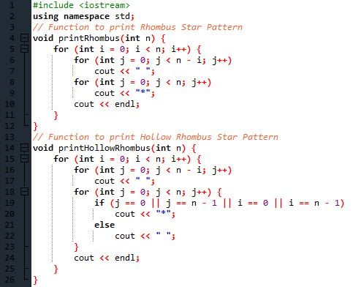**Source Code**

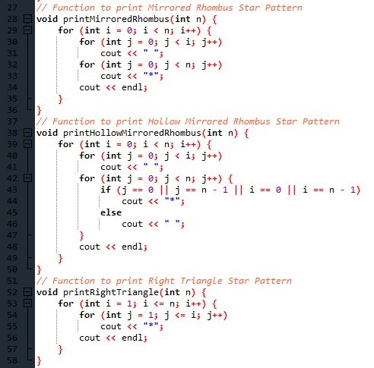

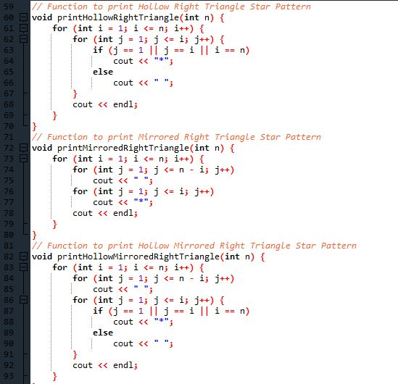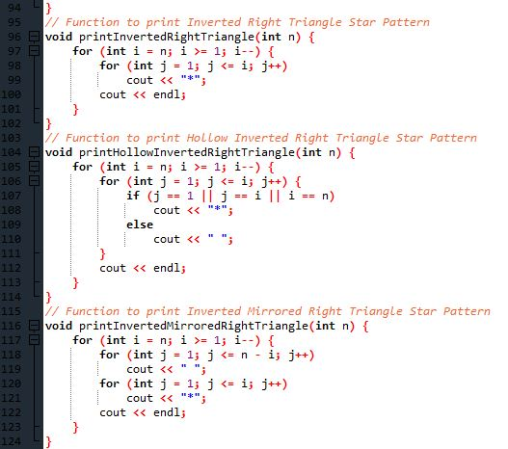

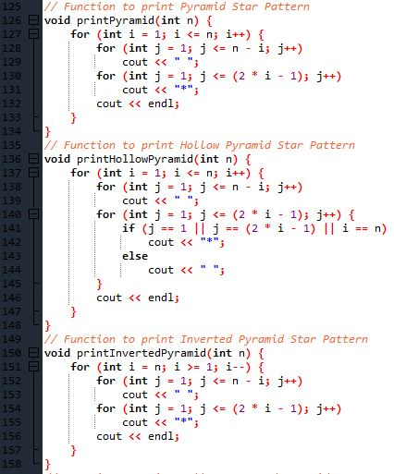

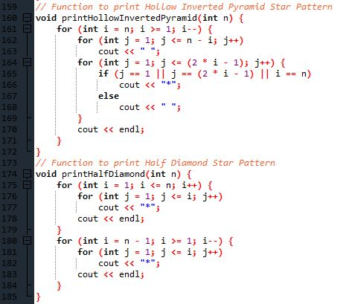

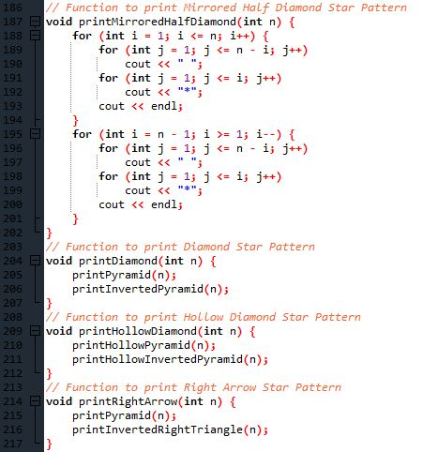

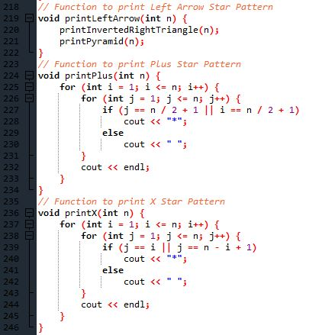

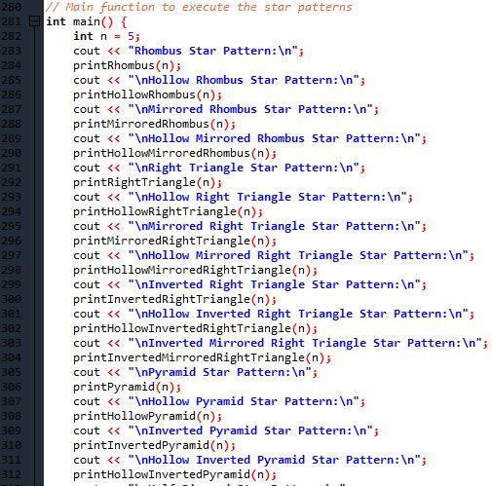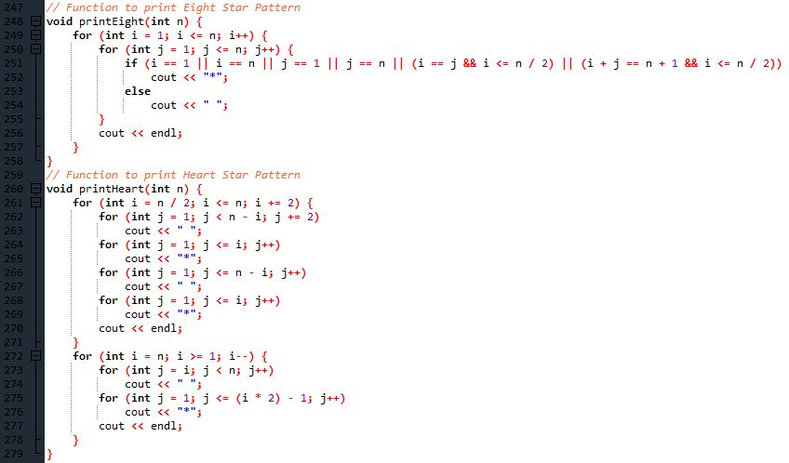

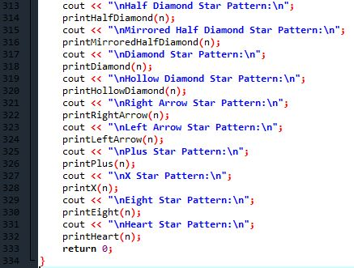

**Output**

